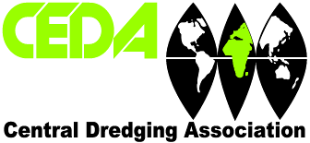

CENTRAL DREDGING ASSOCIATION UK

2022 Nominations for Elected Members of the CEDA UK Committee

I ………………………………. nominate the following who have declared themselves willing to stand for election as a Member of the United Kingdom Section Committee of the Central Dredging Association.

Title__________________________________________________________

Full name of candidate__________________________________________

Name of seconder______________________________________________

Signature of seconder__________________________________________

Note:

The written consent of the nominee/s should be returned with this form, together with a description of his/her present position and main interests and activities (no more than 100 words).

Signed……………………............. Date………………………………..

Please return this form by midday on Wednesday 16th February 2022 to:

Shelagh Fleming
Shelagh.fleming@ice.org.uk

NOTE: Owing to Covid 19 restrictions we regret no postal nominations can be accepted but forms signed by proposers, seconders and candidates may be submitted separately provided such forms are marked appropriately.

